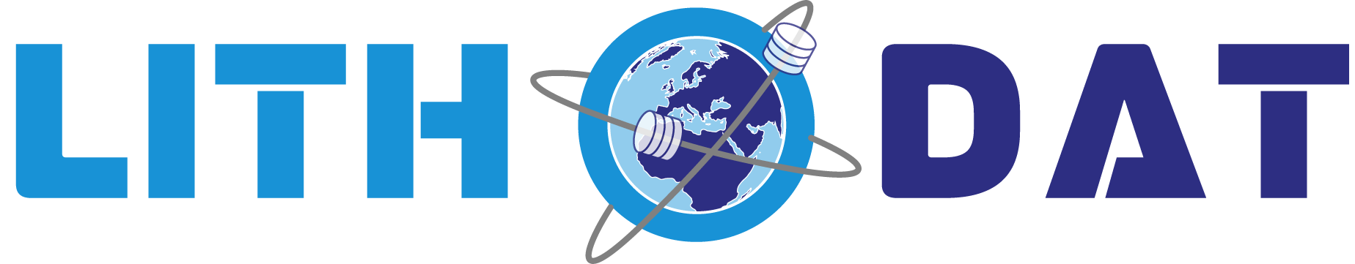

EarthBank Project Summary
National Geoscience Data Platform for FAIR
Geochemistry & Geochronology

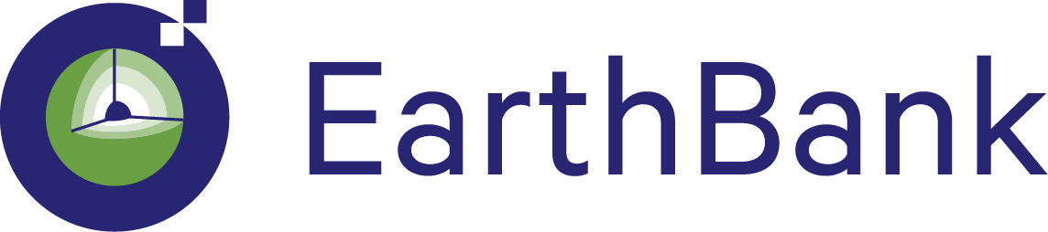

GDAC-SA Advanced Analytics Platform RFQ
Lithodat Pty Ltd
ABN: 63 627 008 904

Project Overview: EarthBank is a $21 million national initiative integrating over $100 million in analytical instrumentation across 10 Australian university laboratories into a single FAIR-aligned digital platform. Co-developed by Lithodat Pty Ltd and AuScope Geochemistry Network, the platform demonstrates direct alignment with GDAC-SA requirements through proven capability in national-scale data standardization, multi-agency collaboration, and advanced geospatial analytics.

1. Overview
EarthBank (https://ausgeochem.auscope.org.au) is Australia's national cloud-based public repository for geochemistry, geochronology, isotopes, and thermochronology data. Co-developed by Lithodat Pty Ltd and AuScope Geochemistry Network, EarthBank represents a $21 million investment in national research infrastructure funded by the Australian Research Council (ARC) and administered through AuScope Ltd.
The platform consolidates analytical data from over $100 million in laboratory instrumentation across 10 Australian universities, making Australia's geoscience research outputs Findable, Accessible, Interoperable, and Reusable (FAIR). This directly mirrors GDAC-SA's mandate to centralize and standardize geoscience data at a national scale.

2. History & Funding
AuScope was established in 2006 as Australia's national geoscience research infrastructure provider through NCRIS, receiving over $260 million in direct Commonwealth investment and catalyzing $340 million total from all sources.
EarthBank evolved from AusGeochem (2019) to become a flagship $21 million national initiative, integrating over $100 million in analytical instrumentation from 10 university facilities into a unified FAIR-compliant digital platform. This substantial investment demonstrates Australia's recognition of national geoscience data infrastructure as critical research capability—the paradigm GDAC-SA seeks to implement for Saudi Arabia.

3. Key Collaborators
- Universities: Ten Australian laboratories (Curtin, Melbourne, ANU, UWA, Macquarie, Queensland, Adelaide, Monash, Tasmania, Wollongong) integrated into single FAIR-aligned platform.
- Government: Geoscience Australia and all state geological surveys collaborate on national isoscape mapping and geochemical baselines, demonstrating multi-agency capability applicable to GDAC-SA.
- Industry: 15% of users from industry (BHP, AngloAmerican, Chalice Mining), demonstrating translational value for mineral exploration.
- Museums: Museums Victoria collaboration digitized 43,500 historical specimens; 80,000+ additional specimens targeted, showcasing legacy data rescue capability relevant to GDAC-SA.
- International: OneGeochemistry initiative (global data standardization), GPlates community (tectonic-geochemical integration), EarthScope (USA), EPOS (Europe), IGSN e.V.
- Leadership: Professor Brent McInnes (Project Director, John de Laeter Centre, Curtin University).

4. Platform Capabilities
EarthBank supports six major analytical data types: U/Pb geochronology, Ar/Ar dating, fission-track thermochronology, (U-Th)/He thermochronology, major/trace element geochemistry, and thermal history modeling. EarthBank is powered by LithoSurfer – Lithodat's online software for interacting with geological data at scale. It provides scalable infrastructure for advanced geospatial analysis required by EarthBank and machine learning integration via REST API. Some examples of the features available in EarthBank include deep time reconstruction, swath profiles, chemistry dashboards, IDW interpolation, 3D visualization, DOI/IGSN minting, shapefile export, and comprehensive REST API for ML integration.

4.1 LithoPlates: Deep-Time Reconstruction
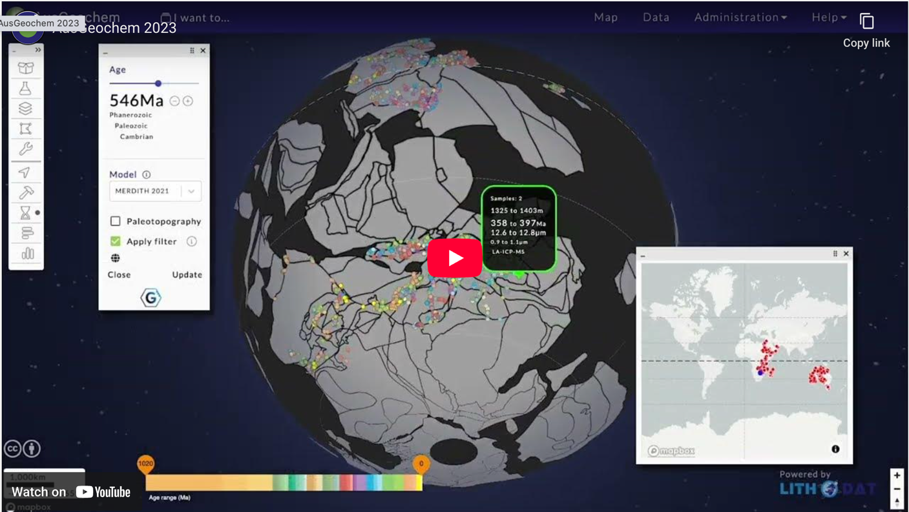
Figure 1: LithoPlates enables deep-time paleogeographic reconstruction of geochemical data using 7 plate tectonic models to 1.8 Ga. This 4D capability (x, y, z, time) supports temporal analysis for mineral system formation through geological time—essential for GDAC-SA's advanced analytics requirements.

4.2 Swath Profile Analysis
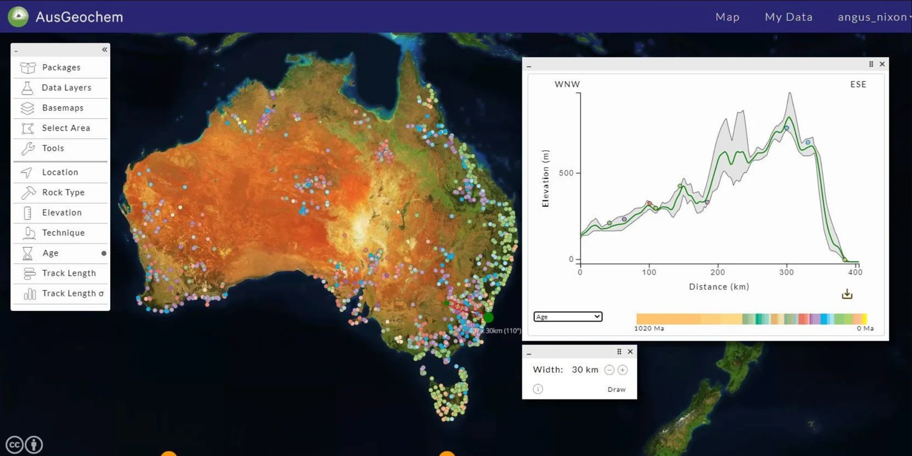
Figure 2: Swath profile tool enables elevation and geochemical analysis along user-defined transects. This advanced spatial analytics capability supports mineral exploration targeting and tectonic interpretation—directly applicable to GDAC-SA's geospatial analysis requirements.

4.3 Interactive Chemistry Dashboards
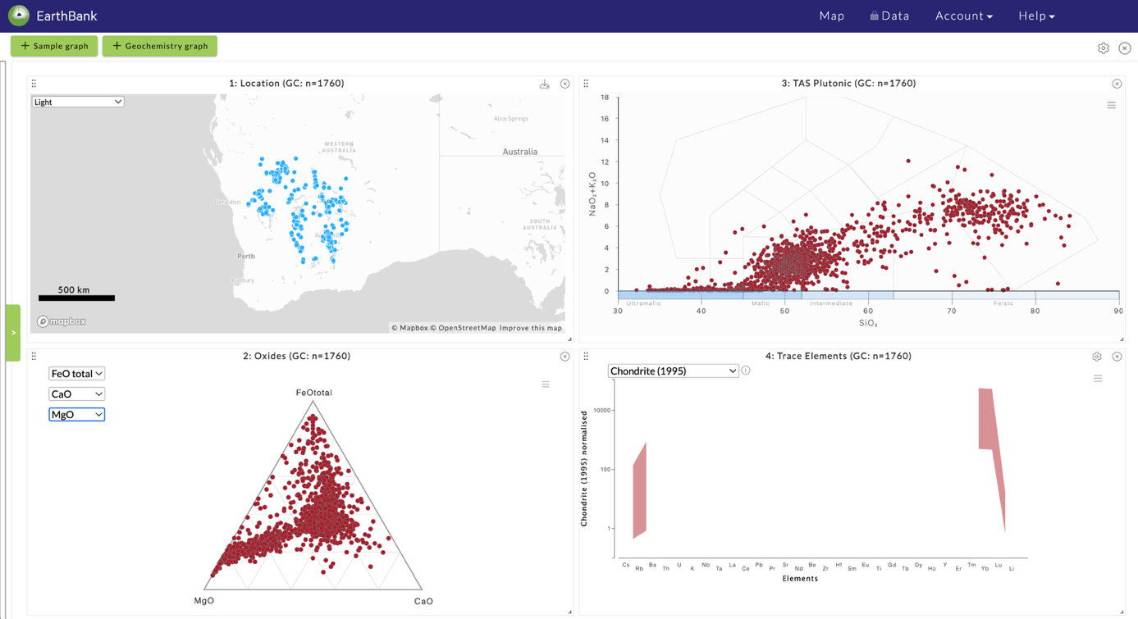
Figure 3: Real-time geochemical dashboards with ternary plots (FeO-CaO-MgO oxides), TAS diagrams (Total Alkali-Silica plutonic classification), and spider diagrams (multi-element plots normalized to Chondrite 1995) enable rapid rock classification and geochemical interpretation—supporting GDAC-SA's advanced data visualization needs.

5. FAIR Data & Impact
- CoreTrustSeal Certification: Highest international standard for trusted repositories, independently validating world-class data stewardship—demonstrating governance rigor required for national geological survey infrastructure.
- FAIR Principles: Findable, Accessible, Interoperable, Reusable data implementation enables research publication pipelines, national isotopic mapping, geochemical baselines, and museum digitization at scale.
- Global Leadership: OneGeochemistry initiative participation positions Australia as global leader in FAIR geoscience data infrastructure through internationally harmonized workflows.
- Economic Impact: $15 ROI for every $1 invested (Lateral Economics), $912M mineral exploration value, $458M gold discoveries, $35M annual mining efficiencies.
- Future Capabilities: National isoscape mapping (Geoscience Australia partnership), GPlates integration for 4D mineral system analysis, expanded OneGeochemistry data sharing.

6. Publications & Recognition
1. Boone, S.C., Dalton, H., Prent, A., Kohlmann, F., Theile, M., Noble, W., et al. (2022). AusGeochem: An Open Platform for Geochemical Data Preservation, Dissemination and Synthesis. Geostandards and Geoanalytical Research, 46(2), 245-259. DOI: 10.1111/ggr.12419
- Highly cited establishing EarthBank as international reference for FAIR geochemical platforms. Demonstrates community-agreed schemas and collaborative development applicable to GDAC-SA's multi-stakeholder environment.
2. Boone, S.C., Kohlmann, F., Noble, W., Theile, M., Beucher, R., Kohn, B., et al. (2023). A geospatial platform for the tectonic interpretation of low-temperature thermochronology Big Data. Scientific Reports, 13, 8581. DOI: 10.1038/s41598-023-35776-3
- Demonstrates advanced analytical capabilities for thermochronology Big Data with GPlates integration for 4D reconstruction—showcasing complex temporal analyses essential for GDAC-SA advanced analytics.
For verification of project performance and technical details, contact:
Prof. Brent McInnes
AuScope Earthbank Director
b.mcinnes@curtin.edu.au

